Richard Quinn– Autobiography cont’d

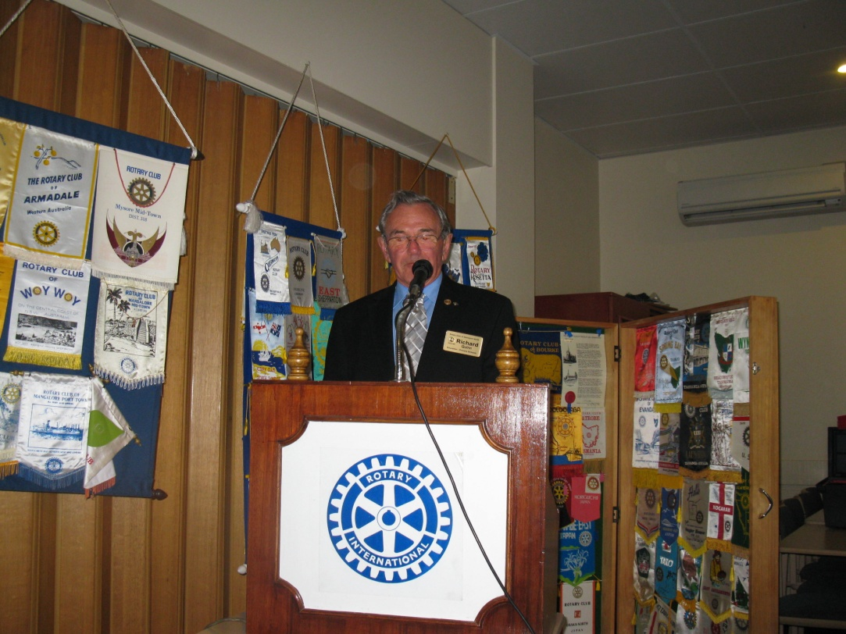

Past President Richard continued with his story from last week and fielded additional questions from the members.

He explained how his Great Grandfather in 1848 was sent here from Ireland at age 16 for some trivial offence. This brings home the society that people lived in at the time!

After 4 years at Smithton School, Richard was appointed in 1979 to the Nixon Street School. He shared how with computers in their infancy, he oversaw a school program whereby every child had access to a class computer and the school was introduced to a very early version of email. Being the mid-1980’s, this was well before the invention of the internet as we all know it.

Unfortunately Richard was later required to retire due to health problems which as told by Richard, led to some pretty funny stories. Richard, members are wondering how many gate posts eventually got knocked over?

Thanks again for continuing with your story this week

Page 4

Program
2012-13 – Week 17- Meeting No 1904- 38th Year

 | 1 November | 8 November | 15 November
Speakers /Activity | Rotary Friendship  Team Exchange from NZ | Stuart Richey  Tasmanian Fishing Industry | Kevin Shadbolt (PDG)  Rotary Foundation
Chairman | Peter Chalk | Bruce Gowans | Buz Green
Presidents Table | Ian McCullam  Julian O’Brien | Gerald O’Dea  John O’Donnell | Glenn O’Halloran  Rod Owers
Reception | Mike Kelly  Kay Kidd | Rockie Lee  Ian Macleod | Kevin Matthews  Ian McCallum
Rotary Info  (Job Talk) | Bobby Gray | Mark Temple-Smith | Bruce Gowans
Meetings | Sub Committees | Committees | Sub Committees
Birthdays |  | Gennie Mullen 03/11 | Richard Barnard 12/11  Dimity Titmus 09/11
Rotary Anniversary (this Club) | Mark Nugent 29/10 3yrs

Previous Meeting – 25th October 2012

Attendance: 42 members (81%)
Make Ups: Steve Rockliff, Mark Temple-Smith
Apologies: Richard Colbeck, John Cook, Steve Rockliff
Leave of absence: Esley Dunham, Phil Gregory, Mark Temple-Smith
Guests:
Visiting Rotarians:
Apologies: (Before 11am Wednesday) Contact attendance officer Rockie Lee
email: rockiejlee@bigpond.com or phone 0427 870 964
Club website: www.rotarydevnorth.org.au ECLUB: (www.rotaryeclubone.org)
Devonport Motor Show: www.devonportmotorshow.com
Rotary International web site: www.rotary.org

Page 1

President

Tonight we welcome eight guests from the South island of New Zealand on the Friendship exchange program. By now our visitors will have been here nearly two weeks and no doubt have enjoyed the company and hospitality of many Tasmanian Rotarians.

We welcome Lester and Frances Paul from RC Waimate, Lance and Joan Wensley from RC Timaru, High and Elizabeth Tapper from RC Invercargill and Allan and Shirley Barr from RC Timaru South.

Last week we filled our night in with a little extra autobiography and questions of Rotarian Richard Quinn. Richard must have anticipated that I was going to call on him to add on or finish off the previous week’s talk as he had his notes with him. Now that’s what I call organized! Thanks again Richard. These autobiographies are a great way of getting to know our fellow members especially from the point of view of our younger and newer members.

The past weekend proved to once again be a winner for Prostate cancer with the holding of the 4 ball golf Ambrose tournament. 32 teams entered and everyone enjoyed preparing the barbecue and the fellowship that went with it. Congratulations to Rotarian Peter Colgrave for such a well organized event as well as to the team led by Rotarian Richard Barnard. Plenty of comments like “see you next year”!

Tonight everyone will see the new banners that have been organized by PP Rotarian Mike Doyle and the Membership and Public Relations committee. I encourage their use in all our public activities.

Quote for the week
“Failure is inevitable, useful and educational. Just don’t give up – stay focused and it will pay off”

President John

Page 2

Events

Sun 25 Nov Orana roast lunch 10.30 am to 1.30 pm
Mon 10 Dec Film Night – Life of π (in 3D)
Fri 21 Dec Breakfast in the Park
Sun 24 Mar13 Devonport Motor Show

Reports

- Beer Winners – The first and possibly only three Rotarians to read the President’s Report last week were Bruce Buxton, Mike Doyle and Kay Kidd. Please see Gavin this week to collect your liquid prize.
- Rotary Information – Bernt Genssen shared an interesting article from The Rotarian on “Polio Plus” (Rotary’s polio eradication program). When starting this program in 1986 there were 1,000 children per day getting polio and nearly half of those were from India. Following a prolonged and concentrated program focusing on India (along with the rest of the world), India has now had a full year without an incident of polio and with very few in prior years.
- Secretary Tony Hartley presented a thankyou letter from Giant Steps Tasmania DNR’s sponsorship of Zachary.
- Fundraising – Kevin Matthews reported that Ross Stewart and Leigh Titmus won the $5 draws for the Caulfield Cup and Vicki Matthews won the $2 draw.

Page 3

