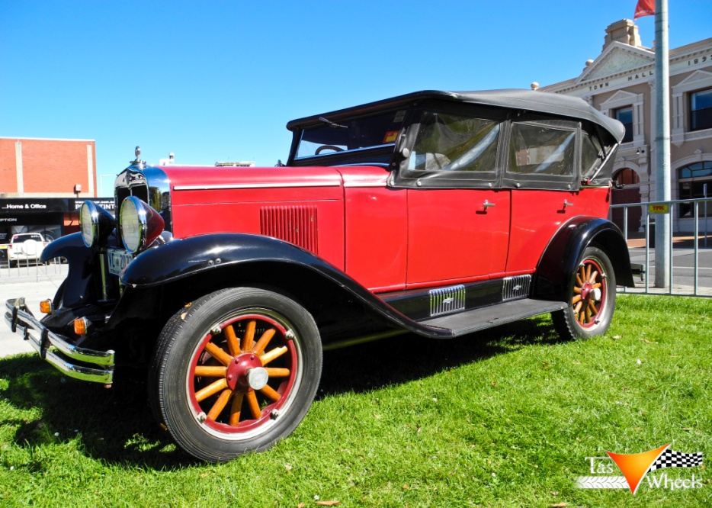
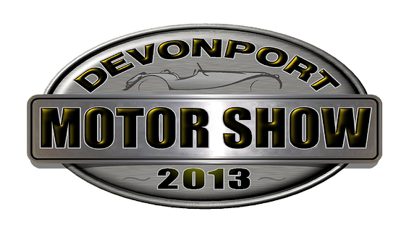http://www.devonportmotorshow.com

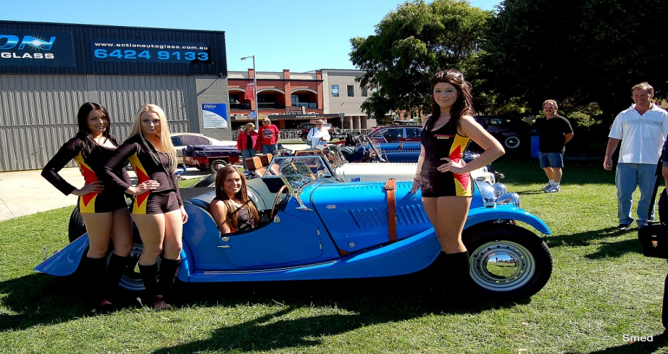
Page 4

Program
2012-13 – Week 34- Meeting No 1921- 38th Year

 | 7 March | 14 March | 21 March
Speakers /Activity | Matthew Atkins  DCC Initiative | Peter Killick  Construction Industry | Rod Owers  Motor Show Briefing
Chairman | John O’Donnell | Glenn O’Halloran | Alan Pattison
Presidents Table | Esley Dunham  Bob Farr | Bernt Genssen  Bobby Gray | Bruce Gowans  Buz Green
Reception | John Cook  Lance Cox | Paul Crabtree  Mike Doyle | Tony Davies  Esley Dunham
Rotary Info  (Job Talk) | Seelan Nair | Mike Doyle  (Conference Committee) | Mike Doyle  (Conference Committee)
Meetings | Sub-Committees | Committees | Sub-Committees
Birthdays

Rotary Anniversary (this Club) | Peter Chalk (17yrs)  Leigh Titmus (17yrs)

Previous Meeting – 28th February 2013

Attendance: 42 members (80%)
Make Ups: Paul Crabtree, Mark Temple-Smith
Apologies: R Colbeck, P Colgrave, B Gowans, K Matthews, R Owers, S Poke, R Lee
Leave of absence: Ian Hutchinson, Peter Mullen
Guests:
Visiting Rotarians:
Apologies: (Before 11am Wednesday) Contact attendance officer Rockie Lee
email: rockiejlee@bigpond.com or phone 0427 870 964
Club website: www.rotarydevnorth.org.au ECLUB: (www.rotaryeclubone.org)
Devonport Motor Show: www.devonportmotorshow.com
Rotary International web site: www.rotary.org

Page 1

President’s Report

This week has seen us a lot closer to having a home for our club equipment with a home for the container , the catering caravan and the gear trailer which has been purchased from Brigg’s Welding.

LeighTitmus had a small working bee last saturday and club members can expect to be asked to help out getting our gear organised soon.

This year we have purchased rather more equipment for our club to use which has not been budgeted for. At last Thursday’s board meeting the club approved the purchase of another two 6 x 3 metre tents for use at our functions . Their immediate purpose will be for use at the Motor Show.

I believe that the equipment purchased will be of great benefit in the future and should make it easier for us to operate.

Last week Past President Richard Barnard asked for leave of absence for a month from 21st of March to the 25 of April. I would not normally raise this matter but I wish to communicate to members that we continue to give Richard what support we can with his now sole carer’s responsibility at home. His daughter has also relocated to study in Melbourne and he has taken a directorship on the Board of Carer’s Tasmania which is partly contributing to his request for time out.

Quote for the week

“We can do anything if….We want to achieve it….We believe we can achieve it….We enjoy trying to achieve it”

President John

Page 2

Events

Wednesday Nights Twilight Bowls (6.00-8.30pm) - weekly
Sat 16th March Birthday function at Matt McConnell’s home – all welcome
Sun 24 Mar Devonport Motor Show

Reports

- Mike Kelly passed on the Devonport Triathalon’s appreciation for the club’s assistance last weekend and confirmed that the club would be receiving a donation of $500.
- Community Service – Seelan reported that volunteers were sought for cleaning up the Nitro Circus on the 10th of March. A sizeable donation would be made by the Circus to the club if sufficient members were available.
- Membership and Public Relations – Mike Doyle reported that the club now has vinyl club banners for outdoor use. Mike also thanked Julian for his efforts in setting up the DNR Facebook page.
- Mike Doyle advised that the Longford District Conference was set for 15/16/17 March and hosted by the Rotary Club of Longford. DNR will have a stand to promote our own 2014 conference. Mike has also asked for any members attending the Longford Conference to give him some feedback (good and bad!) to assist with organising our own 2014 conference.
- Devonport Motor Show – Leon Peck gave thanks to members of his committee (Mac Russell, Rod Owers, Steve Rockliff, Wayne Tucker, John Cook, Glenn O’Halloran, Rick Campbell and Ian Macleod) for their efforts to date. Leon also thanked Seelan for his “over and above” efforts in finding 5 independent sponsors for the DMS.
- Rotary Info Talk – Ian Murcott treated us to a very interesting talk on his occupation as a “Petroleum Dispensing Technician”. As a 24 hour business, Ian has several “typical” client profiles and members seemed most interested in stories about Ian’s “After 10pm” shoppers. Senior members were also particularly excited by Ian’s offer of driveway service!

Page 3

