Some more car chow pics……..

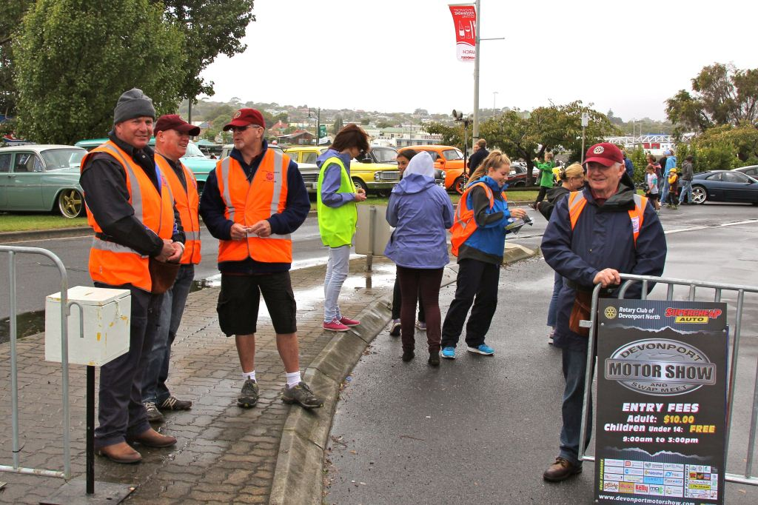

Page 4

Program
2012-13 – Week 40- Meeting No 1927- 38th Year

 | 18 April | 25 April | 2 May
Speakers /Activity | Rowen Tongs  Army Recruitment | Anzac Day  No Meeting | Rotaract - Central Coast
Chairman | Leon Peck |  | John Phillips
Presidents Table | Rockie Lee  Ian MacLeod |  | Kevin Matthews  Ian McCallum
Reception | Kay Kidd  Rockie Lee |  | Ian MacLeod  Kevin Matthews
Rotary Info  (Job Talk) | John O’Donnell |  | Glenn O’Halloran
Meetings | Sub Committees
Birthdays

Rotary Anniversary (this Club) | Leon Wootton (24yrs) |  | Peter Mullen (1yr)

Previous Meeting – 11th April 2013

Attendance: 40 members (76%)
Make Ups: R Lee, B Buxton, P Chalk, B Green, M Nugent, J O’Brien, J van der Woude
Apologies: R Colbeck, L Wooton, R Campbell, M Nugent, G Bull
Leave of absence: R Barnard, P Crabtree, I Hutchinson, P Mullen
Guests:
Visiting Rotarians:
Apologies: (Before 11am Wednesday) Contact attendance officer Rockie Lee
email: rockiejlee@bigpond.com or phone 0427 870 964
Club website: www.rotarydevnorth.org.au ECLUB: (www.rotaryeclubone.org)
Devonport Motor Show: www.devonportmotorshow.com
Rotary International web site: www.rotary.org

Page 1

President’s Report

Due to last week’s rearrangement because the guest speaker was unavailable, the club was given an opportunity to consider the future arrangement of communications within and by the club. Julian Obrien’s address on social media, websites and facebook was a timely session on educating the club about it future direction.

The first consideration that has been discussed a few times is the continuation of what has been over the years a very successful club bulletin. The printing production of this bulletin costs us approximately $900 a year. The time and effort to get it to the meeting each week is a job that is not very easy for the incoming President to fill each year. If the club formulated a standard form on email it could be quite easily replace and simplify the steps taken to keep club members informed. Currently all members receive the bulletin by email before the meeting. This week I shall ask for votes from all members as to whether or not to keep producing the printed bulletin and the matter will be taken to the board and the President Elect.

Rotarian Gerald O’Dea gave a good address on Rotary Health and this week we have received mail asking for our club’s financial contribution to the cause. Again this will be considered for disbursements at the normal time. If anyone wishes to comment feel free to do so.

We are fast approaching the RYDA program in May which will be the next big effort the club will be involved in. Maybe we could see a few different faces experience it from within the club this year even if only for a day. Following the first week of RYDA it seems that Rotarian PP Glen O’Halloran has excelled himself again in organising a Bruny Island weekend with about 30 participants.

Quote for the Week
“Change your thoughts and you change your world”
Norman Vincent Peale 1898-1993

President John

Page 2

Events

RYDA Dates Queenstown – May 15th
Camp Clayton – May 20th, 21st , 22nd , 23rd
Camp Clayton – June 11th , 12th , 13th , 14th

Reports

- Footy Tipping – Don’t forget to see Peter Colgrave to collect any winnings.
- There were no other reports this week.

Another car show pic............

Page 3

